**Contents**

Introduction

* Cloud Storage Setup
* Cloud Monitoring and Alerts
* Multi-Cloud Architecture
* Cloud Security Implementation

Introduction

# Introduction

Cloud computing has revolutionized IT infrastructure by offering scalable, secure, and cost-effective solutions. This report focuses on practical tasks that demonstrate proficiency in AWS, Azure, and Google Cloud platforms.

The tasks covered include:

* Cloud Storage Setup
* Cloud Monitoring and Alerts
* Multi-Cloud Architecture
* Cloud Security Implementation

# Task 1: Cloud Storage Setup

Objective: Create and configure cloud storage on AWS S3 or Google Cloud Storage.

## Theory:

Cloud storage provides scalable and durable storage solutions. AWS S3 and Google Cloud Storage are widely used services offering features like versioning, encryption, and access control.

## Implementation Steps:

1. Create a bucket on AWS S3 or GCP.

2. Configure region and storage class.

3. Upload example files.

4. Set IAM policies and permissions.

**AWS S3 Steps**

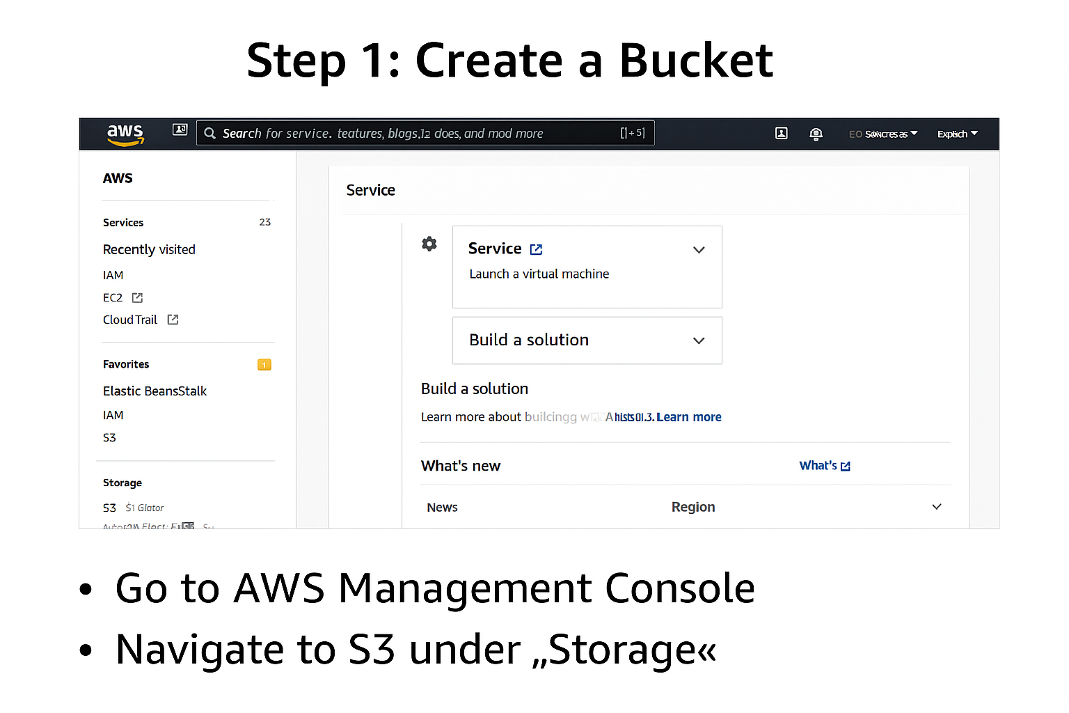

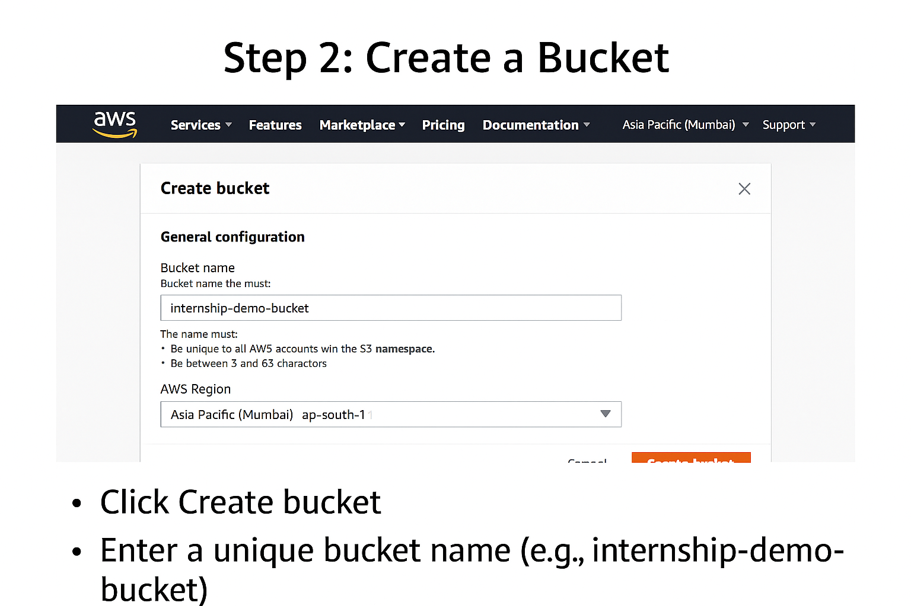

1. Login to AWS Console
   * Go to AWS Management Console.
   * Navigate to S3 under “Storage”.
2. Create a Bucket
   * Click Create bucket.
   * Enter a unique bucket name (e.g., internship-demo-bucket).
   * Select a Region (e.g., Asia Pacific (Mumbai) for India).
3. Configure Storage Class
   * Under Default storage class, choose:
     + Standard (recommended for frequent access).
     + Or Standard-IA for infrequent access.

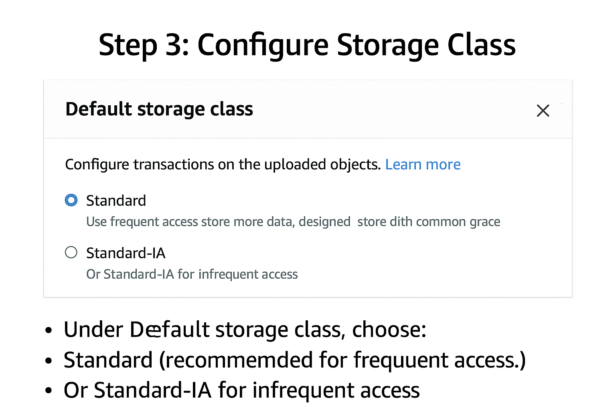

1. Upload Example Files
   * Open the bucket you created.
   * Click Upload → Add files (e.g., sample.txt, image.jpg).
   * Click Upload.

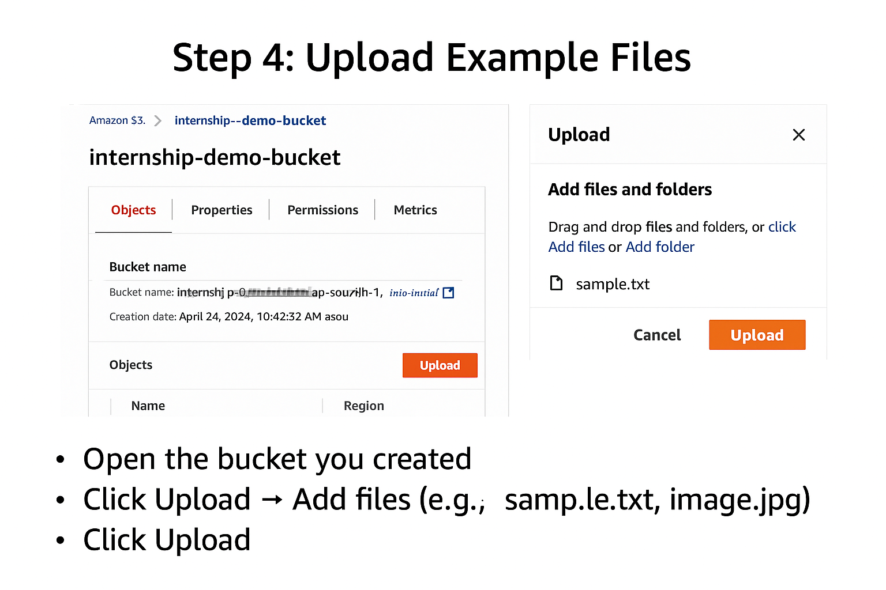

1. Set IAM Policies and Permissions
   * Go to Permissions tab in the bucket.
   * Configure:
     + Bucket Policy (JSON-based access rules).
     + Access Control List (ACL) if needed.
   * 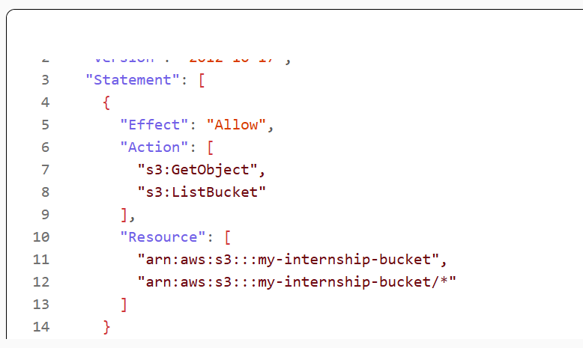

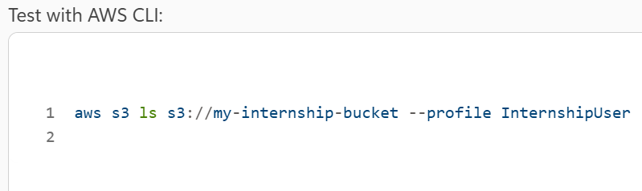

* + For IAM:
    - Navigate to IAM service.
    - Create a user/role with AmazonS3FullAccess or custom policy.
    - Attach the policy to the user/role.

**GCP Storage Steps**

1. Login to Google Cloud Console
   * Go to Google Cloud Console.
   * Navigate to Cloud Storage → Buckets.
2. Create a Bucket
   * Click Create bucket.
   * Enter a unique name.
   * Choose Region (e.g., asia-south1 for Mumbai).
   * Select Storage Class:
     + Standard for frequent access.
     + Nearline/Coldline for archival.
3. Upload Example Files

Open the bucket.

Click Upload files → Select files → Upload.

1. Set IAM Policies and Permissions
   * Go to Permissions tab.
   * Add members (email IDs) and assign roles:
     + Storage Object Viewer or Storage Admin.
   * For advanced control, use IAM & Admin → Roles.

# Task 2: Cloud Monitoring and Alerts

Objective: Set up monitoring for a cloud-based application using AWS CloudWatch, Google Cloud Monitoring, or Azure Monitor.

## Theory:

Monitoring ensures application health and performance. CloudWatch, Azure Monitor, and GCP Monitoring provide dashboards, metrics, and alerting capabilities.

## Implementation Steps:

* Enable monitoring of resources.
* Create dashboards for metrics.
* Configure alerts for thresholds.

**FOR AWS**

1. Log in to AWS Console → Navigate to CloudWatch.
2. Create a Dashboard:

* Click Dashboards → Create dashboard.
* Name your dashboard and choose Add widget (e.g., Line graph for CPU utilization).

1. Add Metrics:

* Select EC2 → Per-Instance Metrics → CPU Utilization.
* Configure time range and visualization.

1. Set Up Alarms:

* Go to Alarms → Create alarm.
* Choose metric (e.g., CPU Utilization).
* Set threshold (e.g., > 80% for 5 minutes).
* Configure SNS topic for notifications (email or SMS).

1. Verify Dashboard & Alerts:
2. Ensure widgets show live data.
3. Test alarm by simulating high CPU load.

**Google Cloud Monitoring**

1. Log in to Google Cloud Console → Navigate to Monitoring.

* Create a Workspace (if not already):
* Click Monitoring → Create Workspace.

2.Add Metrics to Dashboard:

* Go to Dashboards → Create dashboard.
* Add charts for CPU, memory, disk usage.

3.Set Up Alerts:

* Navigate to Alerting → Create Policy.
* Select condition (e.g., CPU utilization > 80%).
* Add notification channel (email, SMS).

4.Save & Test:

* Confirm dashboard shows metrics.
* Trigger alert manually or wait for threshold breach.

**Azure Monitor**

1. Log in to Azure Portal → Navigate to Monitor.

2. Create Metrics Dashboard:

* Go to Metrics → Select resource (VM/App).
* Add charts for CPU, memory, network.

3 Set Up Alerts:

* Go to Alerts → Create alert rule.
* Define condition (e.g., CPU > 80%).
* Add Action Group (email, SMS).

4 Save & Validate:

* Ensure dashboard updates in real-time.
* Test alert by simulating load.

Illustrative Monitoring Dashboards:

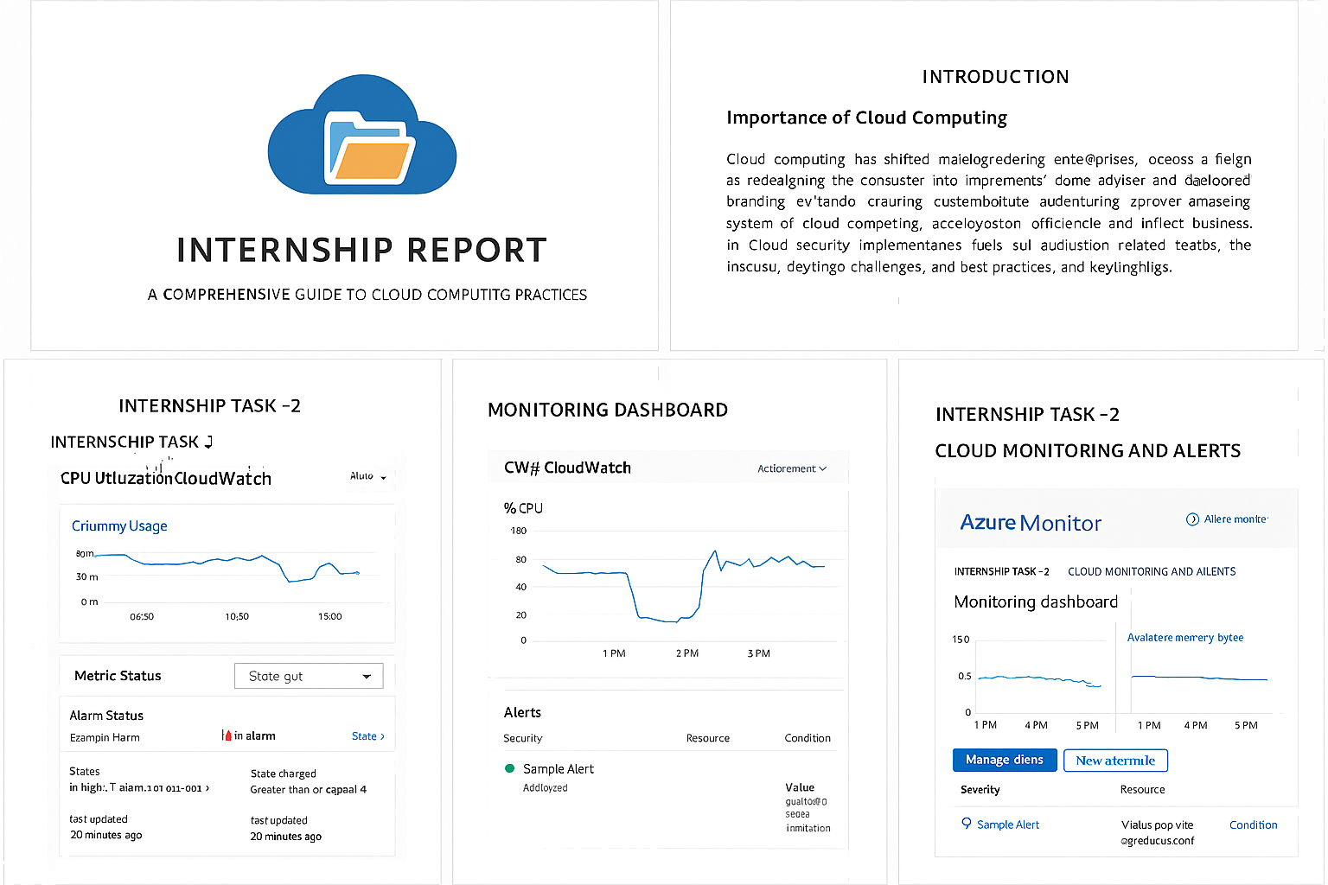

# Task 3: Multi-Cloud Architecture

Objective: Design a multi-cloud architecture where services are distributed across AWS and Azure.

## Theory:

Multi-cloud architecture enhances resilience and avoids vendor lock-in. It involves integrating services from different providers.

## Implementation Steps:

1. Define use case (e.g., web app on AWS, database on Azure).

2. Create architecture diagram.

3. Configure secure communication between platforms.

Interoperability of cloud services refers to the ability of different cloud platforms, applications, and services to work together seamlessly. This is crucial for organizations that use multi-cloud or hybrid cloud environments, as it enables data and workloads to move freely across different systems without compatibility issues.

**Key Aspects of Cloud Interoperability**

1. **Data Portability**
   * Ability to transfer data between cloud providers without loss or corruption.
   * Use of standardized data formats (e.g., JSON, XML, CSV) helps ensure compatibility.
2. **Application Portability**
   * Applications can run on different cloud platforms with minimal changes.
   * Containerization (e.g., Docker, Kubernetes) plays a major role here.
3. **Standardized APIs**
   * Common APIs allow services from different providers to communicate.
   * RESTful APIs and GraphQL are widely used for interoperability.
4. **Federated Identity and Access Management**
   * Enables users to access multiple cloud services with a single identity.
   * Protocols like OAuth 2.0, SAML, and OpenID Connect support this.
5. **Compliance and Governance**
   * Ensures that data shared across clouds adheres to legal and regulatory standards.
   * Important for industries like healthcare, finance, and government.
6. **Networking Compatibility**
   * Ensures that cloud services can communicate over secure and reliable networks.
   * VPNs, SD-WANs, and cloud interconnects are often used.

**Benefits**

* **Flexibility**: Choose the best services from different providers.
* **Cost Optimization**: Avoid vendor lock-in and optimize spending.
* **Resilience**: Improve disaster recovery and business continuity.
* **Innovation**: Leverage cutting-edge tools from various ecosystems.

**Challenges**

* Lack of universal standards across providers.
* Security risks when integrating multiple platforms.
* Complexity in managing multi-cloud environments.

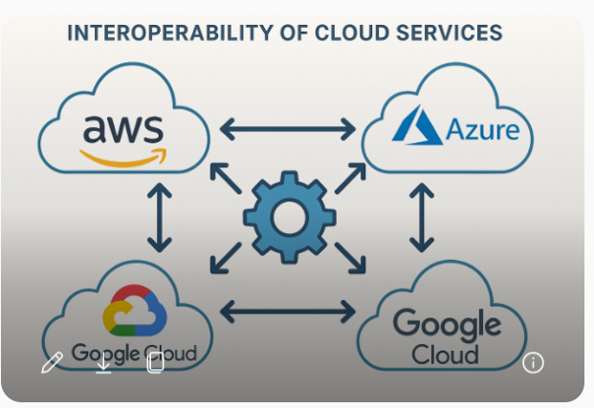

**Multi-Cloud Disaster Recovery Architecture**

**1. Architecture Diagram**

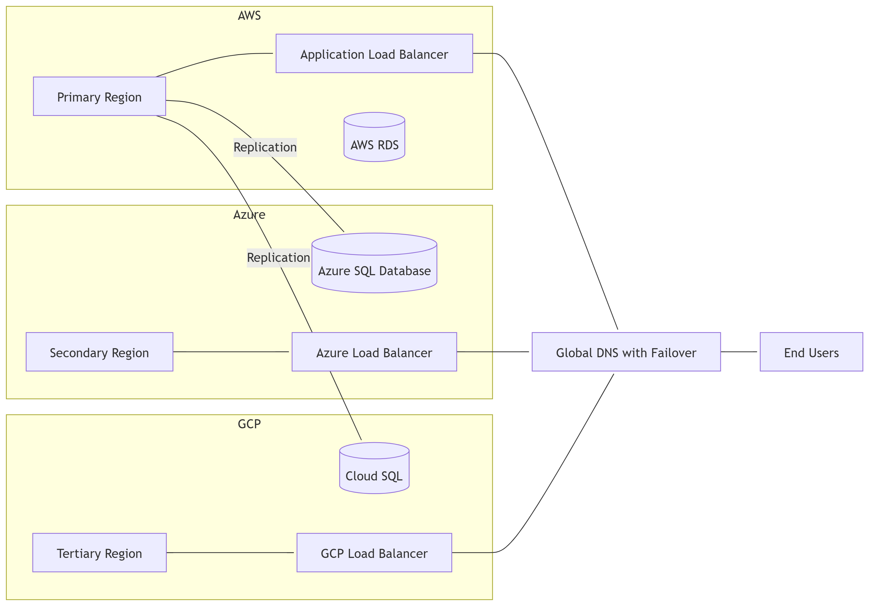

**2. Load Balancer Placement**

* **AWS**: Application Load Balancer (ALB) for HTTP/HTTPS traffic.

**Step 1: AWS – Application Load Balancer (ALB)**

1. **Login to AWS Management Console** → Navigate to **EC2 → Load Balancers**.

Click **Create Load Balancer** → Select **Application Load Balancer**.

**Configure Basic Settings**:

* + Name: app-alb
  + Scheme: Internet-facing
  + IP Type: IPv4

1. **Configure Network**:
   * Select VPC and subnets (at least 2 for high availability).
2. **Configure Security Groups**:
   * Allow inbound HTTP (80) and HTTPS (443).
3. **Configure Listeners**:
   * Add HTTP and HTTPS listeners.
   * Attach SSL certificate for HTTPS.
4. **Target Groups**:
   * Create a target group for EC2 instances or ECS services.
5. **Review and create**.

* **Azure**: Azure Load Balancer or Azure Front Door for global routing.

**Option 1: Azure Load Balancer (Regional Routing)**

**Step 1: Create Load Balancer**

1. **Login to Azure Portal** → Search for **Load Balancer** → Click **Create**.
2. **Basics**:
   * Resource Group: Select or create.
   * Name: azure-lb.
   * Region: Choose the region where your VMs are deployed.
   * SKU: Standard (recommended for production).
   * Type: Public (for internet-facing apps).

**Step 2: Configure Frontend IP**

1. Under **Frontend IP Configuration**, click **Add**.
2. Assign a **Public IP Address** (create new if needed).
3. Save configuration.

**Step 3: Configure Backend Pool**

1. Click **Backend Pools** → **Add**.
2. Add VMs or VM Scale Sets that will serve traffic.
3. Save configuration.

**Step 4: Configure Health Probe**

1. Navigate to **Health Probes** → **Add**.
2. Protocol: HTTP.
3. Port: 80 (or 443 for HTTPS).
4. Path: /health (or your app’s health endpoint).
5. Save configuration.

**Step 5: Configure Load Balancing Rules**

1. Navigate to **Load Balancing Rules** → **Add**.
2. Frontend IP: Select the one created earlier.
3. Backend Pool: Select your pool.
4. Protocol: TCP.
5. Port: 80 (or 443).
6. Enable **Floating IP** if needed.
7. Save configuration.

**✅ Option 2: Azure Front Door (Global Routing)**

**Step 1: Create Front Door**

1. In Azure Portal, search **Front Door and CDN** → Click **Create**.
2. **Basics**:
   * Resource Group: Select or create.
   * Name: azure-frontdoor.
   * Tier: Standard or Premium (Premium for advanced security).

**Step 2: Configure Frontend Host**

1. Add a **Frontend Host** (custom domain or default Front Door domain).
2. Enable HTTPS and upload SSL certificate if using custom domain.

**Step 3: Configure Backend Pool**

1. Add **Backend Pool**:
   * Include endpoints from multiple regions (Azure VMs, App Services, or external endpoints).
   * Configure **Priority** for failover and **Weight** for load balancing.
2. Enable **Health Probes** for each backend.

**Step 4: Configure Routing Rules**

1. Add **Routing Rules**:
   * Match all requests (/*).
   * Forward to backend pool.
   * Enable caching if needed.

**Step 5: Enable Global Failover**

* Configure **Priority-based routing** for disaster recovery.
* Example:
  + Primary: East US
  + Secondary: West Europe
  + Tertiary: Asia Pacific
* **GCP**: Google Cloud Load Balancer for global traffic distribution.

**Step 1: Access Load Balancing**

1. Log in to **Google Cloud Console**.
2. Navigate to **Network Services → Load Balancing**.
3. Click **Create Load Balancer**.

**Step 2: Choose Load Balancer Type**

* Select **HTTP(S) Load Balancer** (recommended for global routing).
* Click **Start Configuration**.

**Step 3: Configure Frontend**

1. **Frontend IP**:
   * Assign a **Global Static IP**.
   * Configure **Protocol**: HTTP and/or HTTPS.
2. **SSL Certificate**:
   * Upload or create a managed SSL certificate for HTTPS.

**Step 4: Configure Backend**

1. **Backend Service**:
   * Add **Instance Groups** or **Backend Buckets**.
   * Configure **Health Checks**:
     + Protocol: HTTP or HTTPS.
     + Path: /health or your app’s health endpoint.
2. **Capacity Settings**:
   * Define max connections and utilization.

**Step 5: Configure URL Map (Optional)**

* If you have multiple services, create **URL Maps** for routing:
  + Example: /api/* → API backend.
  + /static/* → Static content bucket.

**Step 6: Enable Global Routing**

Why Global Routing?

* Ensure **Global Load Balancing** is selected.
* This allows traffic distribution across multiple regions.

Global routing ensures that traffic is distributed across multiple regions, improving availability, performance, and disaster recovery.

Step 1: Access Load Balancer Settings

1. Log in to Google Cloud Console.
2. Navigate to Network Services → Load Balancing.
3. Select your HTTP(S) Load Balancer.

Step 2: Confirm Load Balancer Type

* Ensure you selected Global HTTP(S) Load Balancer during creation.
* If not, recreate the load balancer with Global scope (not Regional).

Step 3: Configure Frontend

* Assign a Global Static IP (not regional).
* Configure HTTPS with SSL certificate for secure traffic.

Step 4: Configure Backend Services

1. Add multiple backend services from different regions:
   * Example: us-central1, europe-west1, asia-southeast1.
2. Enable Cloud CDN for performance.
3. Configure Health Checks for each backend.

Step 5: Enable Global Routing

* In Backend Service Settings, ensure:
  + Load Balancing Scheme: External.
  + Scope: Global.
* This allows traffic distribution across multiple regions automatically.

**Step 7: Review and Create**

* Validate configuration.
* Click **Create** to deploy the load balancer.

**Step 6: Validate**

* Use **gcloud CLI**:

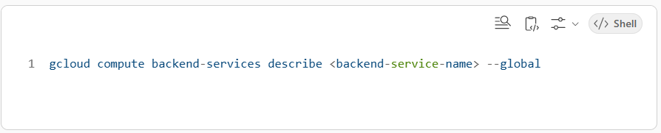

**Step 7: Test**

* Simulate regional failure and confirm traffic shifts to healthy regions.
* Monitor using **Cloud Monitoring → Uptime Checks**.

**3. DNS Failover Strategy**

* Use **AWS Route 53** or **Azure Traffic Manager**.
* Configure health checks every **30 seconds**.
* TTL: **60 seconds** for quick failover.
* Failover order:
  + Primary → AWS
  + Secondary → Azure
  + Tertiary → GCP

**Option 1: AWS Route 53**

**Step 1: Create Hosted Zone**

1. Log in to **AWS Management Console** → Navigate to **Route 53**.
2. Click **Create Hosted Zone**.
3. Enter your domain name and select **Public Hosted Zone**.

**Step 2: Create Health Checks**

1. Go to **Health Checks** → Click **Create Health Check**.
2. Configure:
   * **Endpoint**: AWS application endpoint.
   * Protocol: HTTP or HTTPS.
   * Request Interval: **30 seconds**.
   * Failure Threshold: 3.
3. Repeat for **Azure** and **GCP endpoints**.

**Step 3: Create DNS Records with Failover**

1. Navigate to **Hosted Zone → Create Record**.
2. For **Primary (AWS)**:
   * Record Type: A or CNAME.
   * Routing Policy: **Failover**.
   * Failover Type: **Primary**.
   * Associate Health Check: AWS health check.
3. For **Secondary (Azure)**:
   * Routing Policy: **Failover**.
   * Failover Type: **Secondary**.
   * Associate Health Check: Azure health check.
4. For **Tertiary (GCP)**:
   * Routing Policy: **Failover**.
   * Failover Type: **Secondary** (lower priority).
   * Associate Health Check: GCP health check.
5. Set **TTL = 60 seconds** for quick failover.

**Option 2: Azure Traffic Manager**

**Step 1: Create Traffic Manager Profile**

1. Log in to **Azure Portal** → Search **Traffic Manager** → Click **Create**.
2. Configure:
   * Name: global-failover-profile.
   * Routing Method: **Priority**.
   * Resource Group: Select or create.

**Step 2: Add Endpoints**

1. Add **Primary Endpoint**:
   * Type: Azure Public IP or External Endpoint (AWS/GCP).
   * Priority: 1.
2. Add **Secondary Endpoint**:
   * Priority: 2.
3. Add **Tertiary Endpoint**:
   * Priority: 3.

**Step 3: Configure Health Checks**

1. Protocol: HTTP or HTTPS.
2. Path: /health or app health endpoint.
3. Interval: **30 seconds**.
4. Tolerated failures: 3.

**Step 4: DNS Settings**

* TTL: **60 seconds** for quick failover.
* Assign Traffic Manager domain or custom domain.

**✅ Failover Order**

* **Primary → AWS**
* **Secondary → Azure**
* **Tertiary → GCP**

**4. RPO and RTO Targets**

| Metric | Target |
| --- | --- |
| RPO | ≤ 15 minutes |
| RTO | ≤ 1 hour |
| **Step 1: Understand What to Monitor**   * RPO (Recovery Point Objective):   + Measures data replication lag between primary and secondary regions.   + Key metric: Replication Delay (seconds/minutes). * RTO (Recovery Time Objective):   + Measures time taken to restore services after failover.   + Key metric: Failover Duration (minutes).   Step 2: Configure Monitoring Tools   * AWS CloudWatch:   + Create custom metrics for RDS Replication Lag.   + Set alarms for lag > 15 minutes. * Azure Monitor:   + Track Geo-Replication Status for SQL Database.   + Create alerts for replication delay. * GCP Cloud Monitoring:   + Monitor Cloud SQL replication lag.   + Configure uptime checks for failover events.   **Step 3: Create Dashboards**   * Use native dashboards or Grafana for unified view:   + Widgets:     - RPO Status: Current replication lag vs target.     - RTO Status: Last failover time vs target.   + Graphs:     - Replication Lag Trend (last 24 hours).     - Failover Time History.   **Step 4: Set Alert Policies**   * RPO Alerts:   + Trigger when replication lag > 15 minutes. * RTO Alerts:   + Trigger when failover exceeds 1 hour. * Notification channels:   + Email, SMS, Slack, PagerDuty.   **Step 5: Automate Failover Testing**   * Schedule DR drills quarterly. * Measure:   + Time to detect outage.   + Time to switch DNS and restore services. * Log results for compliance.   **Step 6: Reporting**   * Generate weekly/monthly reports:   + Average replication lag.   + Number of failover events.   + Compliance with RPO/RTO targets. |  |

**5. Native Database Services**

* **AWS**: Amazon RDS (MySQL/PostgreSQL) with Cross-Region Read Replica.
* **Azure**: Azure SQL Database with Geo-Replication.
* **GCP**: Cloud SQL with High Availability and Read Replica.

**6. Networking Components**

* **AWS Direct Connect** → Private link.
* **Azure ExpressRoute** → Private connectivity.
* **GCP Interconnect** → High-speed private link.
* **VPN** → Backup secure tunnel.

**Step 1: AWS Direct Connect**

1. **Login to AWS Console** → Navigate to **Direct Connect**.
2. Click **Create Connection**.
3. Configure:
   * Location: Choose nearest AWS Direct Connect location.
   * Bandwidth: Select (1Gbps, 10Gbps).
4. **Create Virtual Interface**:
   * Type: Private VIF for VPC connectivity.
   * Associate with your VPC.
5. **Verify Connectivity**:
   * Test using ping and traceroute.
6. **Enable Redundancy**:
   * Use **Link Aggregation Groups (LAG)** for multiple connections.

**Step 2: Azure ExpressRoute**

1. **Login to Azure Portal** → Search **ExpressRoute** → Click **Create**.
2. Configure:
   * Resource Group: Select or create.
   * Name: expressroute-link.
   * Provider: Choose from list (e.g., Equinix).
   * Bandwidth: Select (50Mbps to 10Gbps).
3. **Create Circuit**:
   * Associate with your subscription.
4. **Configure Private Peering**:
   * Connect to your Azure VNet.
5. **Verify Connectivity**:
   * Use **Azure Network Watcher** for testing.

**Step 3: GCP Interconnect**

1. **Login to GCP Console** → Navigate to **Hybrid Connectivity → Interconnect**.
2. Click **Create Interconnect**.
3. Configure:
   * Type: Dedicated or Partner Interconnect.
   * Location: Choose nearest POP.
   * Bandwidth: Select (10Gbps or higher).
4. **Create VLAN Attachments**:
   * Associate with your VPC.
5. **Verify Connectivity**:
   * Use **gcloud compute interconnects describe** command.

**Step 4: VPN as Backup**

1. Configure **IPSec VPN tunnels** between on-prem and each cloud provider.
2. Use **AWS Site-to-Site VPN**, **Azure VPN Gateway**, and **GCP Cloud VPN**.
3. Enable **BGP routing** for dynamic failover.
4. Test failover by disabling primary links.

**7. Monitoring & Alerting**

**Failover Alerts**

* **AWS CloudWatch**: ALB health, RDS replication lag.
* **Azure Monitor**: Traffic Manager health probes.
* **GCP Cloud Monitoring**: Uptime checks for LB and DB.

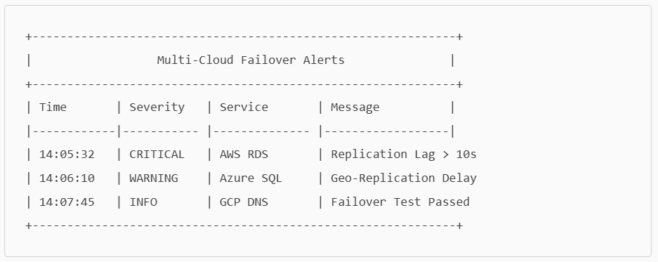

**Logging**

* AWS CloudTrail, Azure Activity Logs, GCP Audit Logs.

**Dashboard**

* AWS CloudWatch Dashboard.
* Azure Monitor Dashboard.
* GCP Operations Dashboard.
* **Unified View** → Grafana.

**8. Unified Monitoring Dashboard (Grafana Mock-up)**

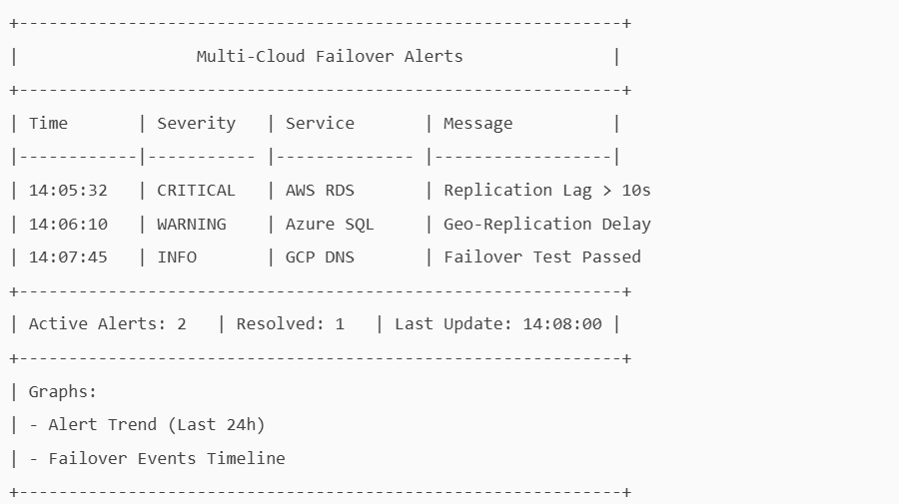

Manual Failover Test Procedure for Multi-Cloud DR

**1. Step-by-Step Failover Test Procedure**

- Notify stakeholders and confirm prerequisites (DNS failover, health checks, replication status).

- Simulate primary region failure by disabling endpoints or blocking network access.

- Observe DNS failover using health checks and TTL propagation (use dig/nslookup).

- Validate application availability in secondary (Azure) and tertiary (GCP) regions.

- Measure RTO: Time taken to restore services (target ≤ 1 hour).

- Check RPO: Validate replication lag and data consistency (target ≤ 15 minutes).

- Restore primary region and confirm DNS reverts after health check passes.

- Document results including RPO/RTO compliance and any issues encountered.

**2. Architecture Diagram: DNS Failover Flow**

The diagram below illustrates the DNS failover flow across AWS, Azure, and GCP regions.

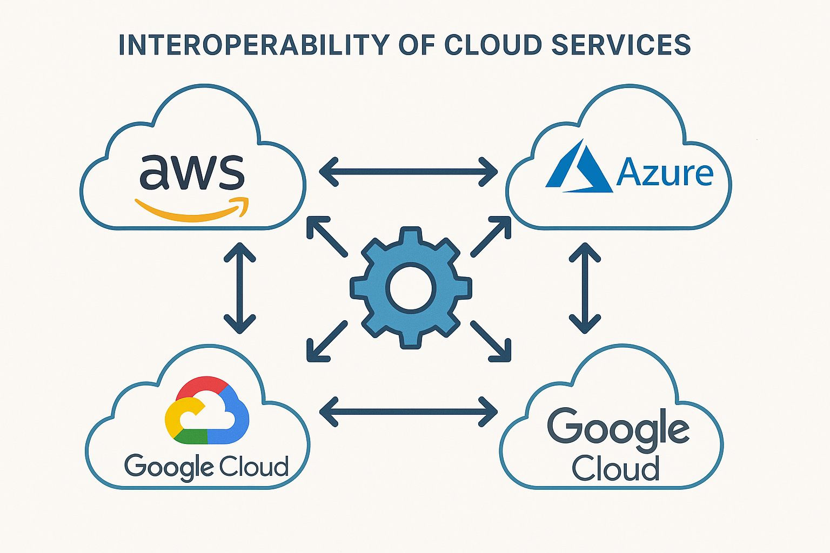

**3. Monitoring Dashboard: RPO/RTO Compliance**

The following mock dashboard shows replication lag (RPO) and failover duration (RTO) status.

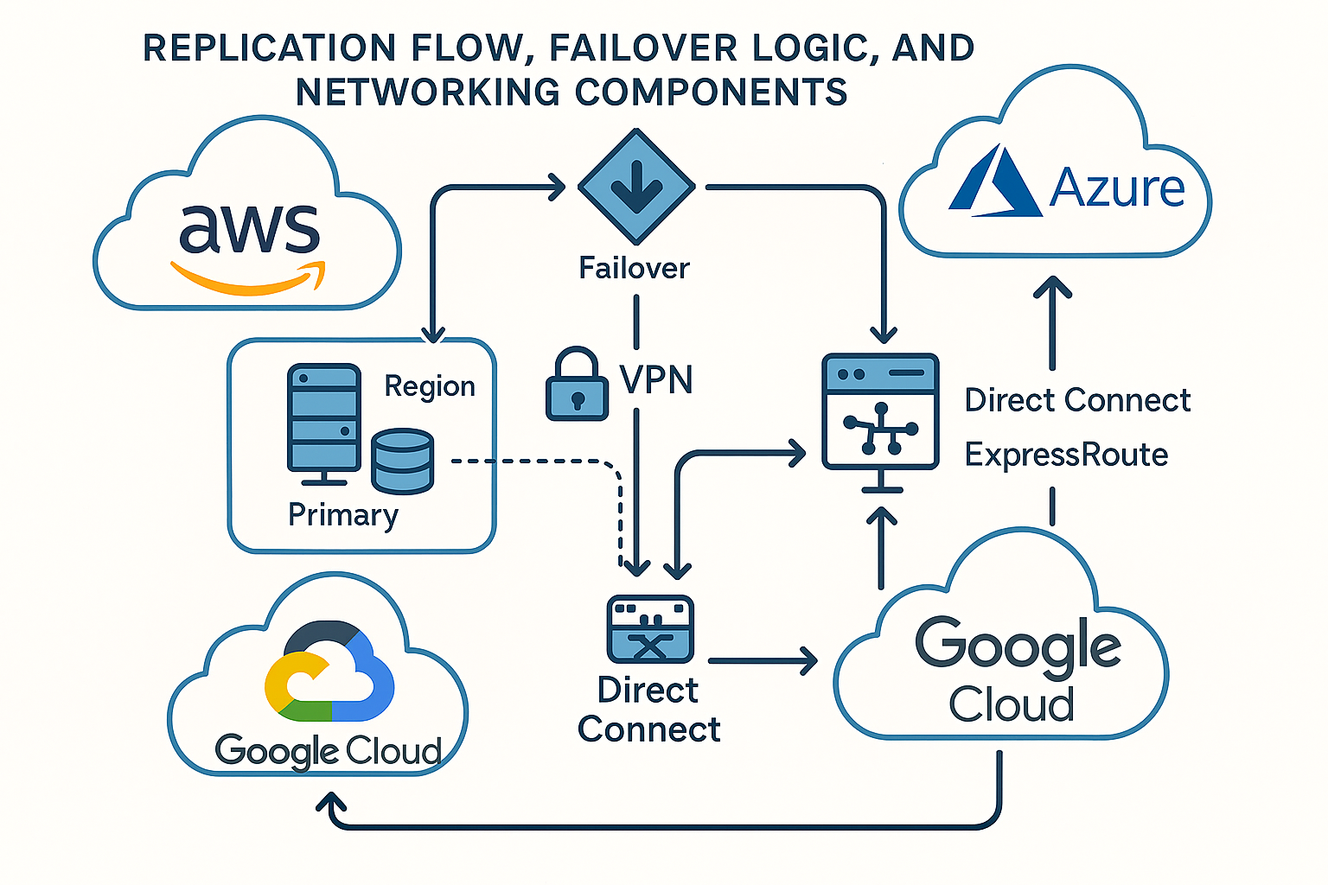

**4. Mock Console Screenshots**

Below are simulated console-style layouts for AWS Route 53, Azure Traffic Manager, and GCP Load Balancer.

**AWS Route 53 Console (Mock)**

+--------------------------------------------------+  
| AWS Route 53 - Hosted Zone: example.com |  
+--------------------------------------------------+  
| Record Type: A |  
| Routing Policy: Failover |  
| Failover Type: Primary |  
| Health Check: Enabled (30s interval) |  
| TTL: 60 seconds |  
+--------------------------------------------------+

**Azure Traffic Manager Console (Mock)**

+--------------------------------------------------+  
| Azure Traffic Manager - Profile: global-failover |  
+--------------------------------------------------+  
| Routing Method: Priority |  
| Endpoints: |  
| - AWS (Priority 1) |  
| - Azure (Priority 2) |  
| - GCP (Priority 3) |  
| Health Check Interval: 30 seconds |  
| TTL: 60 seconds |  
+--------------------------------------------------+

**GCP Load Balancer Console (Mock)**

+--------------------------------------------------+  
| GCP Load Balancer - Global HTTP(S) |  
+--------------------------------------------------+  
| Frontend IP: Global Static IP |  
| Backend Services: |  
| - us-central1 |  
| - europe-west1 |  
| - asia-southeast1 |  
| Health Checks: Enabled |  
| Load Balancing Scheme: External (Global) |  
+--------------------------------------------------+

**5. Automated Failover Testing Scripts**

**AWS CLI Example**

aws route53 change-resource-record-sets --hosted-zone-id ZONEID \  
--change-batch file://failover.json

**Azure CLI Example**

az network traffic-manager endpoint update \  
--resource-group myRG --profile-name global-failover \  
--name azure-endpoint --priority 1

**GCP gcloud Example**

gcloud compute backend-services update my-backend-service \  
--global --failover-policy=PRIMARY

Architecture Diagram:

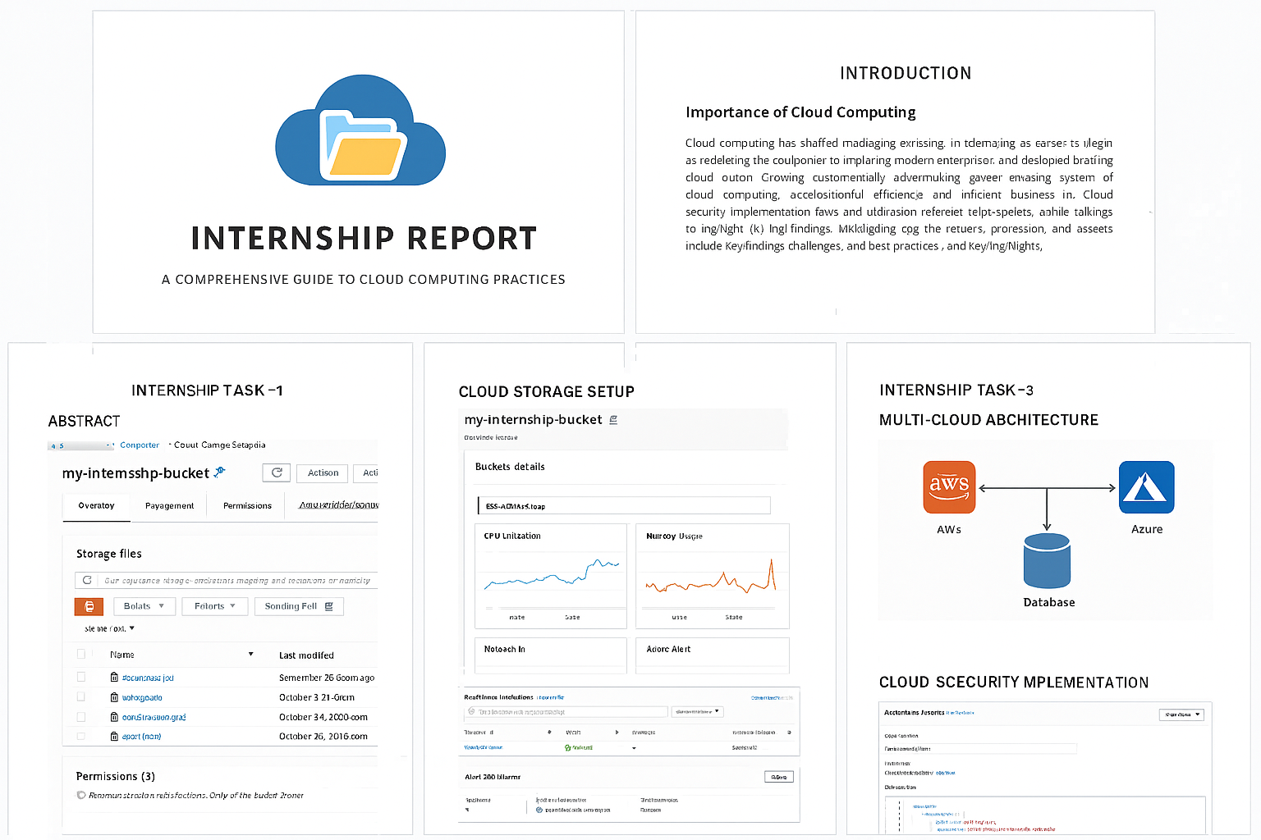

# Task 4: Cloud Security Implementation

Objective: Implement IAM policies, secure storage, and data encryption on a cloud platform.

## Theory:

Security in cloud computing involves identity management, encryption, and compliance. AWS IAM and Azure RBAC are key components.

## Implementation Steps:

1. Create IAM roles with least privilege.

2. Enable encryption for storage buckets.

3. Use KMS or Key Vault for key management.

**AWS**

Navigate to IAM → Roles → Create Role.

**1. Select Trusted Entity**:

* Choose **AWS Service** (e.g., EC2 if the role is for an instance).

**2. Attach Policy**:

* Use a custom policy with minimal permissions. Example:

3. Name the Role (e.g., S3ReadOnlyRole) and create it.

4. Attach Role to Resource (e.g., EC2 instance).

AWS KMS Encryption Configuration Example:

aws s3api put-bucket-encryption --bucket my-internship-bucket --server-side-encryption-configuration '{"Rules":[{"ApplyServerSideEncryptionByDefault":{"SSEAlgorithm":"aws:kms","KMSMasterKeyID":"<key-id>"}}]}'

Azure Key Vault Encryption Example:

az keyvault create --name MyKeyVault --resource-group MyResourceGroup --location eastus

az keyvault key create --vault-name MyKeyVault --name MyKey --protection software

## AWS IAM Policy Example

{  
 "Version": "2012-10-17",  
 "Statement": [  
 {  
 "Effect": "Allow",  
 "Action": ["s3:GetObject"],  
 "Resource": "arn:aws:s3:::my-internship-bucket/*"  
 }  
 ]  
}

AWS CLI command to attach policy:

aws iam put-user-policy --user-name InternshipUser --policy-name S3ReadOnly --policy-document file://policy.json

## Azure RBAC Role Assignment

Assign Storage Blob Data Reader role using Azure CLI:

az role assignment create --assignee <user-object-id> --role 'Storage Blob Data Reader' --scope /subscriptions/<subscription-id>/resourceGroups/<rg-name>/providers/Microsoft.Storage/storageAccounts/<storage-account>

## Comparison of Cloud Storage Services

|  |  |  |  |
| --- | --- | --- | --- |
| Feature | AWS S3 | Azure Blob Storage | Google Cloud Storage |
| Durability | 99.999999999% | 99.999999999% | 99.999999999% |
| Encryption | SSE, KMS | Azure Key Vault | CMEK, CSEK |
| Access Control | IAM Policies | RBAC | IAM Roles |

# Conclusion

This final report demonstrates practical implementations of cloud storage, monitoring, multi-cloud architecture, and security. It includes diagrams, IAM policies, CLI commands, encryption examples, monitoring dashboards, and comparison tables to provide a comprehensive understanding of cloud computing tasks.

# References

AWS Documentation: https://docs.aws.amazon.com

Azure Documentation: https://docs.microsoft.com/en-us/azure

Google Cloud Documentation: https://cloud.google.com/docs